**COST OF SSD VS HHD OVERTIME:**

**INTRODUCTION:**

Solid State Drives (SSDs) and Hard Disk Drives (HDDs) are two primary storage technologies used in computing. SSDs use flash memory for data storage, offering faster read and write speeds compared to traditional HDDs, which use spinning magnetic disks. Over time, advancements in technology, market demand, and manufacturing processes have influenced the cost of SSDs and HDDs.

**SUMMARY:**

The cost of SSDs and HDDs has experienced notable changes over the years due to various factors such as technological advancements, supply and demand dynamics, and shifts in manufacturing processes. Initially, SSDs were significantly more expensive per gigabyte compared to HDDs. However, as SSD technology matured, prices gradually declined, making them more accessible to consumers and businesses. Conversely, HDD prices have remained relatively stable, with minor fluctuations influenced by factors like component shortages and changes in demand.

**DESCRIPTION:**

**1. Evolution of SSD Costs:**

* In the early years of SSD introduction, prices were relatively high, limiting their adoption primarily to high-performance computing applications and enterprise environments.
* As SSD technology advanced and manufacturing processes improved, costs began to decrease steadily. This was driven by factors such as increased production efficiency, higher yields, and economies of scale.
* Consumer demand for faster storage solutions, coupled with declining production costs, led to more competitive pricing in the SSD market.
* The introduction of 3D NAND technology further contributed to cost reductions and increased SSD capacities, making them more attractive alternatives to HDDs.

**2. Stability of HDD Costs:**

* HDD prices have remained relatively stable over the years, with minor fluctuations influenced by factors such as component shortages, natural disasters affecting manufacturing facilities, and changes in demand.
* While advancements in HDD technology have increased storage capacities, the cost per gigabyte has not decreased at the same rate as SSDs.
* HDDs continue to be favored for applications requiring large storage capacities at a lower cost per terabyte, such as data centers and network-attached storage (NAS) systems.

Top of Form

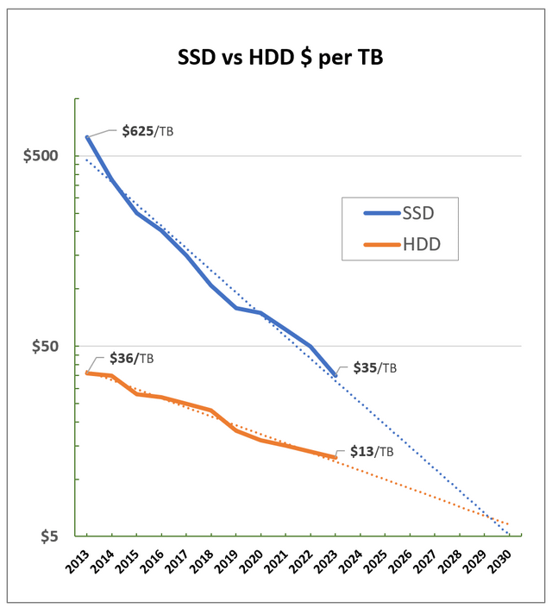

**Conclusion:**

In conclusion, the cost of SSDs and HDDs has followed distinct trajectories over time. SSDs have undergone significant price reductions, making them more competitive with HDDs in terms of cost per gigabyte. This has been driven by advancements in technology, improvements in manufacturing processes, and increased demand for faster storage solutions. On the other hand, HDD prices have remained relatively stable, with incremental improvements in storage capacity but without the same level of cost reduction seen in SSDs. Ultimately, the choice between SSDs and HDDs depends on factors such as performance requirements, budget constraints, and storage needs.